Visualization & Insights
- Pending Deliveries by Country:
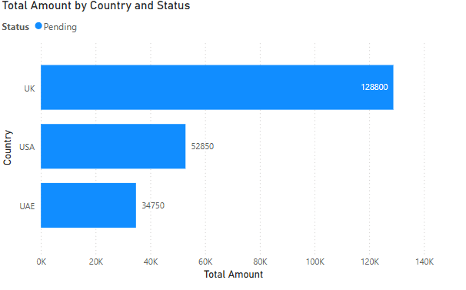
  - Insight: "UK has highest pending deliveries by Total Amount(128800). Need to Investigate logistics delays."
- Order Details by Customer:
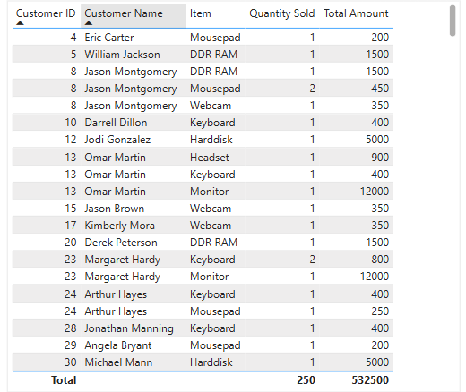

- Maximum Product Purchase by Country:
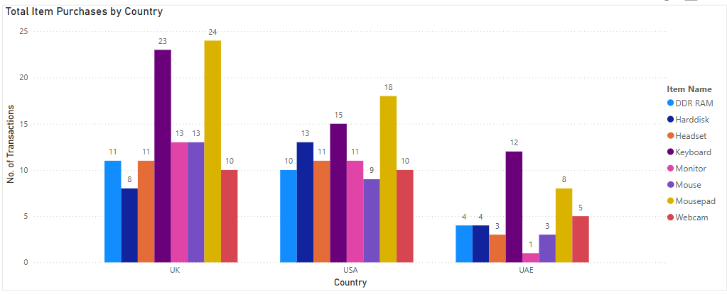
  - Insight: "There seems to be a lot of demand for mousepads in UK and USA. However, in UAE there is more demand for Keyboards."

- Top Products by Age:
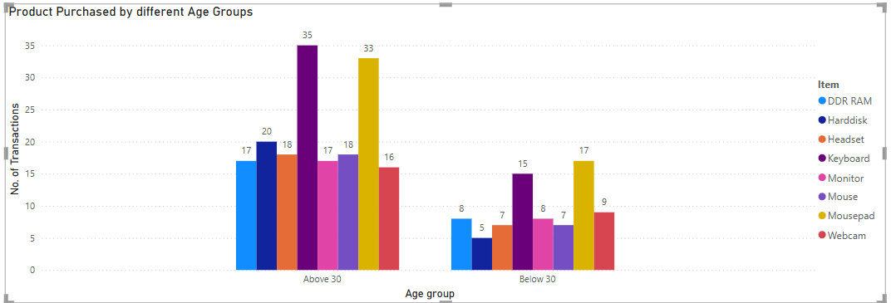
  - Insight: "Keyboards dominate for >=30 while Mousepads for < 30."

- Country Performance:
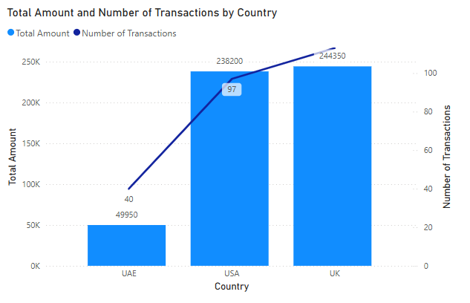
  - Insight: "UAE has the lowest number of transactions and Sales Amount."

